

ACE FAQs

Contents

General Consents Queries 2

Production Consents (PCONs) 4

Flare and Vent Consents (FCONs and VCONs) 4

Onshore Consents 6

Facility Consents 6

EIA Requirements 6

## August 2024

(V1)

# General Consents Queries

Q. What is the Annual Consents Exercise (“ACE”)?

A. ACE is the process to apply to produce Oil and Gas, and to Flare and Vent Gas in the UKCS, Onshore & Facilities for the upcoming year following expiration of current consents.

Q. How will I know when and how to apply?

A. NSTA published guidance and key deadlines for submitting applications for the Annual Consents Exercise on the NSTA website ([Annual Consents Exercise (nstauthority.co.uk)](https://www.nstauthority.co.uk/regulatory-information/licensing-and-consents/consents/annual-consents-exercise/#%3A~%3Atext%3DLicensing%20%26%20consents%2C-Overview%26text%3DThe%20Annual%20Consents%20Exercise%20(%E2%80%9CACE%E2%80%9D)%20provides%20an%20efficient%2Cthe%20North%20Sea%20Transition%20Deal). This webpage is our key point of communications going forward with details of supporting requirements to assist industry to plan with certainty.

Q. What should I do if I can’t meet the deadlines?

A. If you are unable to meet a deadline, please email [consents@nstauthority.co.uk](mailto:consents@nstauthority.co.uk) for the attention of the NSTA Consents & Authorisations team with the background, ensuring this action is taken before the deadline, requesting guidance on next steps – at the earliest opportunity.

Q. Do the deadlines apply to all onshore, Facilities, and offshore annual consents?

A. Yes, the deadlines are the same for all application types.

Q. Will the NSTA email reminders be stopped?

A**.** Correct, reminders were stopped in 2022, and the NSTA has no current plan to reintroduce this process for ACE or wider field consents.

Q. How many Energy Portal contacts can I have in my team?

A. NSTA advises Operators to have a minimum of two working contacts in each role on the Field Consents system who can action applications should they be returned. There is no upper limit.

Q. How do I access applications to prepare and amend?

A. Please speak to your Access Manager who can include people and assign permissions to each person.

An Access Manager in your company will be able to assign permissions via the Team Management link provided you have an existing UK Energy Portal Account.

See screenshots below:

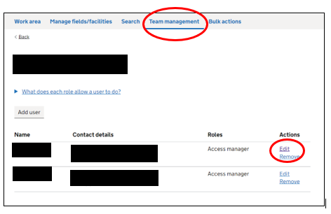

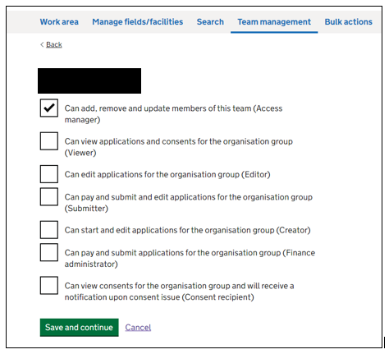

Q. Why have I received an application back in my workbasket?

A. If an application has been returned to you, please check comments boxes for any queries and comments which require a response. Please ensure that queries and comments are addressed promptly. Failure to do this will delay your application progressing.

# Q. I am getting an error message that there is no licence associated with the field.

# If you get an error saying there is no licence associated, please submit a licence assignment application in PEARS. [Petroleum e-business assignments and relinquishment system (PEARS) (nstauthority.co.uk)](https://www.nstauthority.co.uk/regulatory-information/licensing-and-consents/licensing-system/petroleum-e-business-assignments-and-relinquishment-system-pears/)

# The NSTA licensing team will then associate the field with the relevant licence.

Q. I have noticed that my new application in the new service has an old legacy duplicate reference number, how do I correct this to make it unique?

A. There was an issue in the new Field Consents service that meant it allocated duplicate legacy application reference numbers to a small number of ‘new’ applications submitted between 1st July and 1st August 2024. This did not have an impact on any revisions submitted since launch. The issue has been rectified as of 2nd August 2024, new unique reference numbers have been allocated to impacted applications and industry contacts informed via email.

# Production Consents (PCONs)

Q. How do I apply?

A. Applications for the continuation of production in the year following expiry of the current consent are to be submitted using the template for new applications. They cannot be processed via the template for revisions to existing consents.

Q. What happens if I submit an application using the wrong template?

A. If you have submitted your application using the wrong application template, you will be requested to withdraw this application and will be charged for it along with the additional cost for the correct application. If in doubt, please contact us for advice. If however, you wish to change the starting year of the consent or change the duration (Long term, annual or short term (this can be done as un update to the current application with no additional charge.

Q. How long a production consent duration should I apply for and what does NSTA expect the maximum and minimum rates to be based on?

A. Please contact your NSTA Area Team point of contact and they will be able to discuss the appropriate consent duration and rates for your individual field with you ahead of your application in the portal. This will streamline the review process and help ensure we do not have to pass the consent application back to you for revision.

Q. How do I maintain the Valid From date on my long term production consent when submitting a revision?

A. When reviewing all sections of the application prior to submission, do not make any changes to the 'consent duration' tab. This has been pre-set to maintain the dates of your current consent. For example, Consent valid from 1 January 2010 to 31 December 2025.

Q. In the Application Rationale section, which option should I select when completing my production application?

A. The following guidance should be applied to ensure you select the correct option:  
  
**Increase:**

* Compared to the current consented year “**increase**” should be selected where:
  + There is an increase in the averaged oil or;
  + There is an increase in the averaged gas profile or;
  + Any of the years show an increase over the current years consented volumes

**Decrease**

* Compared to the current consented year “**decrease**” should be selected where:
  + There is an decrease in the averaged oil or;
  + There is an decrease in the averaged gas profile or;
  + Any of the years show a decrease over the current years consented volumes

**Extension**

* Should only be selected with prior agreement of the NSTA and will typically relate to unique circumstances are end of field life.

**Other**

* Should be used for applications such as change of operator,

# Flare and Vent Consents (FCONs and VCONs)

Q. How do I apply?

A. Applications for the continuation of Flaring and/or Venting in the year following expiry are to be submitted using the **new application template**, they cannot be processed as revisions to existing consents.

Q. What happens if I apply using the wrong template?

A. If you have submitted your application using the wrong application template, you will be requested to withdraw this application and will be charged for it along with the additional cost for the correct application. If in doubt, please contact us for advice. If however, you wish to change the starting year of the consent or change the duration (Long term, annual or short term (this can be done as un update to the current application with no additional charge.

Q. How do I include a field to a joint Flare/Vent consent?

A. Approval from the relevant NSTA Engineer and other parties in the joint consent is required. Written evidence from each field in the joint consent, stating that they are content with the field being included in the joint consent, is to be attached to the application being submitted via the Field Consents system (in the Supporting Information section).

Q. If you add more than one field to the consent, do you have to fill in a breakdown for each one or a summary for all fields listed?

A. No.

Q. How long a Flare or Vent consent duration should I apply for and what does the NSTA expect the maximum and minimum rates to be based on?

A. Please contact your NSTA Area Team point of contact prior to submitting your application and they will be able to discuss the appropriate consent duration (maximum duration is 1 year) and rates for your field(s). This will streamline the review process and help ensure we do not have to pass the consent application back to you for update.

Q. If the application is submitted prior to the Flare and Vent deadline, are we to provide 12 months of actual data prior to that date?

A. In flare and vent report section of the application you will be asked to confirm “Which year do you have vent report data up to?” and “Which is the latest full month of vent report data you have?”. This will generate a table within those parameters to be populated with data. 12 Months of data should be provided where possible.

Q. Are you anticipating that the ERAP and the flare and vent Management Plan are one in the same?

A. ERAP is an emissions reduction, so that includes power generation, flare and vent. Therefore, the flare and vent Management Plan would be a subset of the ERAP.

Q. If an ERAP is achieving its aims, can an Operator develop the ERAP as they see fit?

A. The NSTA has not given a check list for writing an ERAP, there are guidelines in the flare and vent guidance however the ERAP should be developed and owned by the Operator and should be embedded within your organisation.

Q. Do you expect a vent consent for any venting from crude storage tanks?

A. Yes, we expect that a consent will be needed for releases from any discrete tank vents. But please contact the NSTA if you need to discuss any aspect.

# Onshore Consents

Q. How long a production consent duration should I apply for and what does the NSTA expect the maximum and minimum rates to be based on?

A. Please contact your NSTA Area Team point of contact and they will be able to discuss the appropriate consent duration and rates for your individual field with you ahead of your application in the portal. This will streamline the review process and help ensure we do not have to pass the consent application back to you for revision.

Q. How long a Flare or Vent consent duration should I apply for and what does the NSTA expect the maximum and minimum rates to be based on?

A. Please contact your NSTA Area Team point of contact and they will be able to discuss the appropriate consent duration and rates for your field(s) with you ahead of your application in the portal. This will streamline the review process and help ensure we do not have to pass the consent application back to you for revision. Flare and vent applications in the Field Consents system can only be applied for up to a maximum of 12 months.

Q. When requesting a further production consent are there any requirements prior to the application submission?

A. Yes, the NSTA will require a FDPA to be submitted prior to the application submission.

# Facility Consents

Q. How do I apply?

A. New Flare and Vent Consent applications for Facilities are to be submitted on the Field Consents system. The previous method of emailing your application to the consents team is no longer used.

Q. How long a Flare or Vent consent duration should I apply for and what does OGA expect the maximum and minimum rates to be based on?

A. Please contact your NSTA point of contact [consents@nstauthority.co.uk](mailto:consents@nstauthority.co.uk) and they will be able to discuss the appropriate consent duration (maximum duration is 1 year) and rates for your Facility with you ahead of submission of your application. This will streamline the review process and help ensure we do not have to pass the consent application back to you for revision.

# EIA Requirements

Q. When should I apply to DESNZ EMT for an EIA (ES) or a Screening Direction.

A. Please ensure all DESNZ EMT requirements are applied for prior to submitting your application to the NSTA. For any questions regarding your requirements please contact DESNZ EMT directly.

Q. What are the EIA requirements for my production application.

1. The application will ask the following question - Is this a "project" for the purposes of EIA Regulations 2020?
   * *If 'Yes' is selected, you will then be asked “Have you submitted an EIA screening direction to the Secretary of State or OPRED?” and to provide the reference number.*
   * *If 'No' is selected, and a Field Consent is issued but it is subsequently determined that the Field Consent includes project activity that has not secured SoS' agreement, the consent may be withdrawn (as invalid) which may have consequences for ongoing field operations.*

Q. What happens if the NSTA do not receive a response from DESNZ EMT regarding my project.

A. If your application is for a project under the EIA regs 2020, the NSTA will not be in a position to issue a consent under that application without prior approval from the Secretary of State (DESNZ EMT).