DaRT Objective
The Decommissioning and Repurposing Taskforce’s (DaRT) objective is to support industry to safely reduce the cost of decommissioning in an environmentally responsible manner by ensuring an integrated approach to address the key challenges and opportunities facing the sector, facilitating dialogue between all stakeholders, and working together to deliver strategic direction and tangible improvements.
Logo/Branding:

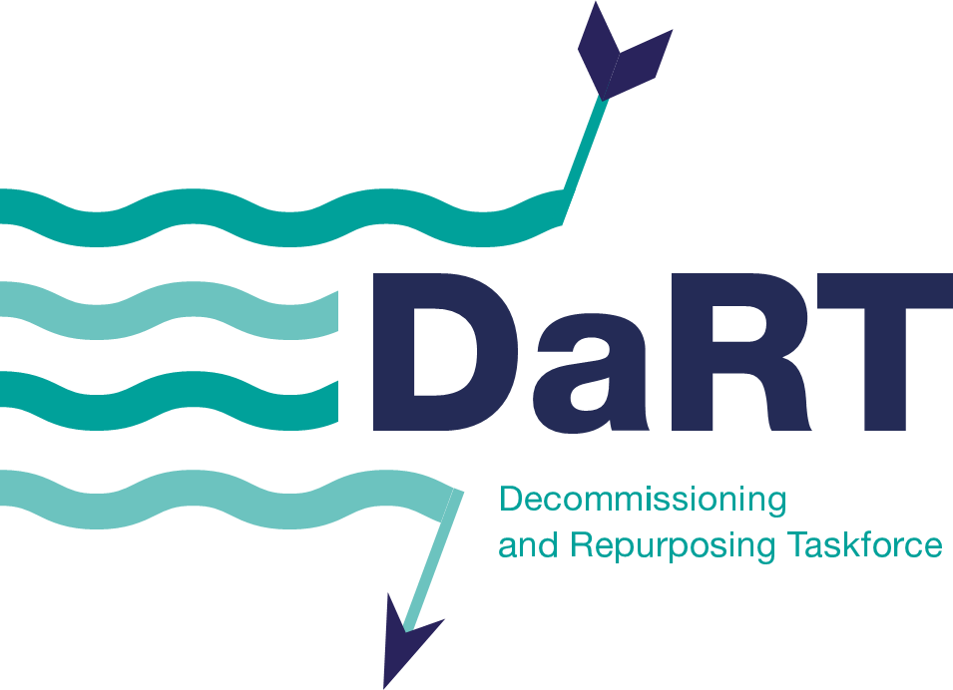

Terms of Reference
Purpose
- To fill the gap, focussing on activities that would otherwise not be delivered by industry.
- Provide leadership and support for the development and deployment of the NSTA’s Decommissioning Strategy and its focus areas.
- Assist the government with meeting its net zero target through supporting integration of decarbonisation and net zero in late-life, repurposing and decommissioning.
- Highlight the key objectives of the groups and bodies represented in the taskforce and collaborate on any current and future challenges or opportunities that the group wish to address or action.
- Ensure that safety and environment is an integral part of decommissioning planning and execution, and that new technologies and digital applications are considered and made visible to all parties.
Membership
- The Decommissioning and Repurposing Taskforce will be co-chaired by industry and the NSTA and co-chairs will be confirmed by letters of appointment issued by the NSTA.
- Members may include the representatives from Operators, Supply Chain, the NSTA, OEUK, Decom Mission, OPRED, HSE and NZTC.
- New additional members to the taskforce must be agreed by the majority of taskforce members.
- All members will hold their post for a maximum period of two years unless extended with agreement from taskforce members.
- Non members may be invited to attend and contribute to/share at specific meetings as identified or proposed by DaRT members.
How we will work
- When participating in task group duties members will represent the UK offshore energy industry as a whole and not their individual companies.
- The Decommissioning and Repurposing Taskforce will create and disband subgroups where appropriate.
- Updates and key messaging from other industry taskforces or groups will be shared and discussed as applicable, to ensure there is alignment on related initiatives or objectives.
- Taskforce members will highlight any perceived or real conflicts of interest to the chair or secretariat.
Meetings
- The Decommissioning and Repurposing Taskforce meetings will be held at least once every two months, hosted online and in one of the Member’s offices.
- Attendance is strongly encouraged. Members may nominate a suitable replacement to attend a meeting only if they are unable to attend.
- The NSTA will provide/arrange secretariat support.
- Decommissioning and Repurposing Taskforce members should submit any pre-read materials/agenda items 5 working days prior to meetings to enable the secretariat to issue/include these a minimum of 3 workings days prior to the meetings.

